**JAR-**



**Folder Hierarchy Maven Project-**

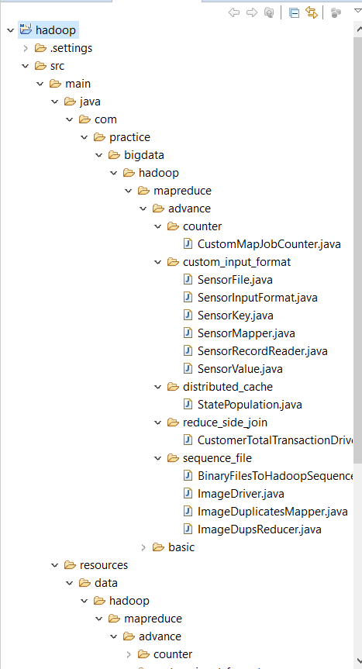

**Commands:**

Custom Counter:

hadoop jar hadoop/jars/hadoop-mapreduce-practice.jar

com.practice.bigdata.hadoop.mapreduce.advance.counter.CustomMapJobCounter

hdfs_filesystem/custommapcounter/input

hdfs_filesystem/custommapcounter/output

Custom Input Key Value and Input Format:

hadoop jar hadoop/jars/hadoop-mapreduce-practice.jar com.practice.bigdata.hadoop.mapreduce.advance.custom_input_format.SensorFile

hdfs_filesystem/custominputformat/input

hdfs_filesystem/custominputformat/output

Distributed Cache:

hadoop jar hadoop/jars/hadoop-mapreduce-practice.jar

com.practice.bigdata.hadoop.mapreduce.advance.distributed_cache.StatePopulation

hdfs_filesystem/ditributedcache/input

hdfs_filesystem/ditributedcache/output

hdfs_filesystem/ditributedcache/cache/state_lookup.dat

Reduce Side Join:

hadoop jar hadoop/jars/hadoop-mapreduce-practice.jar com.practice.bigdata.hadoop.mapreduce.advance.reduce_side_join.CustomerTotalTransactionDriver

hdfs_filesystem/totaltransaction/input/customer

hdfs_filesystem/totaltransaction/input/transaction

hdfs_filesystem/totaltransaction/output

Sequence File:

hadoop jar hadoop/jars/hadoop-mapreduce-practice.jar

com.practice.bigdata.hadoop.mapreduce.advance.sequence_file.BinaryFilesToHadoopSequenceFile

hdfs_filesystem/sequencefile/input

hdfs_filesystem/sequencefile/binaryimages

hadoop jar hadoop/jars/hadoop-mapreduce-practice.jar

com.practice.bigdata.hadoop.mapreduce.advance.sequence_file.ImageDriver

hdfs_filesystem/sequencefile/binaryimages/part-r-00000

hdfs_filesystem/sequencefile/output